**Experiment**: **Single Phase AC Parallel Circuit**

**Objective**: To determine experimentally:

1. Current distribution in a single phase AC parallel circuit.
2. Power and power factor of the circuit.
3. The value of circuit elements R, L & C.

**Equipment**: **(1)** Voltmeter: 150V AC **(2)** Ammeter: 3 Amp AC

**(3)** Wattmeter: 250V, 3 Amp **(4)** Resistor, Choke coil and Capacitor

**Circuit Diagram**: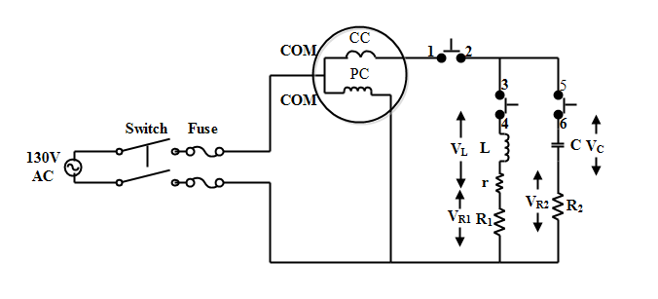

**Theory**: For a given AC parallel circuit, when energized from an AC source, same voltage drops across all parallel connected branches consisting of resistances R1, choke coil L and capacitor C.

For a given ac current I passing through R, L & C; the voltage drop across

Resistance, **VR = IR**,

Pure Inductance, $V_{L}=I(jωL)$,

Pure capacitance, $V_{C}=\frac{I}{jωC}$**=IXc**

Power dissipated in branch one (RL) for parallel circuit shown in above figure.

1) $P_{RL}=I_{1}^{2}{(R}_{1}+ r)=V_{s}I_{1}cosθ_{1}$, Power dissipated in branch two (RC)

2) $P_{RC }=I_{2}^{2}R_{2}=V_{S}I_{2}cosθ_{2}$, Total power is $P_{1}+P_{2}=V_{S}Icosθ$ **= Pt**, Total current **I = I1 + I2** (phasor sum)

3) θ1, θ2 and θ are phase angles between supply voltage and current I1, I2 and I respectively. R1, R2 are the resistances of rheostats connected in branch 1, 2. VS is the supply voltage.

Power factor of parallel circuit, $cosθ=\frac{I_{1}cosθ_{1}+I_{2}cosθ_{2}}{I}=\frac{P_{t}}{V_{s}I}$

$cosθ_{1}= \frac{P_{RL}}{V_{S}I_{1}}=\frac{R_{1}+r}{\sqrt{{\left(R_{1}+r\right)}^{2}+{X_{L}}^{2}}}$

$cosθ_{2}= \frac{P_{RC}}{V_{S}I_{2}}=\frac{R_{2}}{\sqrt{{R_{2}}^{2}+{X_{C}}^{2}}}$

Voltage across resistor R1, **;** Voltage across resistor R2,

Voltage across inductor L, $V_{L}= I_{1}\left(r+jX_{L}\right)$**;** Voltage across capacitor C, $V_{C}= I_{2}\left(-jX_{C}\right)$

**Procedure**:

* Connect the experiment set up as shown in the circuit diagram
* Select AC 130 Volt from the supply panel and switch on the supply.
  + (case -1) W1 = power dissipated in RL branch, keeping switches 1-2 & 3-4 closed, 5-6 open.
  + (case -2) W2 = power dissipated in RC branch, keeping switches 1-2 & 5-6 closed, 3-4 open.
  + (case -3) W = Total power consumed in circuit = W1 + W2, (all switches closed).
* Similarly measure current **I1, I2** and **I** with help of current measurement board.
* Record the readings of the instruments carefully.

**Precautions**:

* Always keep measuring instruments in horizontal position. i.e. table mode.
* Select appropriate range of the instruments. i.e. the range of the instruments should always be more than the existing value of current or voltage in the circuit.
* Don’t touch the resistance even after switching off the supply as it might have been heated up.

**Observations**:

|  |  |  |  |  |  |  |  |  |  |  |  |  |
| --- | --- | --- | --- | --- | --- | --- | --- | --- | --- | --- | --- | --- |
| **CASE** | **Supply (Vs)** | **Voltage across elements** | | | | **Current through switch** | | | **Power consumed** | | | |
| **VR1** | **VR2** | **VL** | **VC** | **1-2**  **I** | **3-4**  **I1** | **5-6**  **I2** | **W­1**  **PRL** | **W2**  **PRC** | **W**  **Pt** |
| **Case 1** |  |  |  |  |  |  |  |  |  |  |  |
| **Case 2** |  |  |  |  |  |  |  |  |  |  |  |
| **Case 3** |  |  |  |  |  |  |  |  |  |  |  |

**Report**:

* Using various relations, calculate R1, R2, XL, XC, L,C assuming the supply frequency as 50Hz.
* Calculate the value of power and power factor of the circuit from above parameters.
* Draw the phasor for one reading when both switches 5-6 and 3-4 are closed.
* What will be the nature of lagging and leading power factor loads? Draw the position of voltage and current phasor for these loads.

**Points to remember:**

1. Multification factor of watt meter used =(Voltage range*Current range*pf of wattmeter)/Max scale deflection
2. Actual reading of wattmeter = multification factor * reading of wattmeter